6.

http://yii-book.app/index.php?r=test/index and a success message will be displayed as follows:

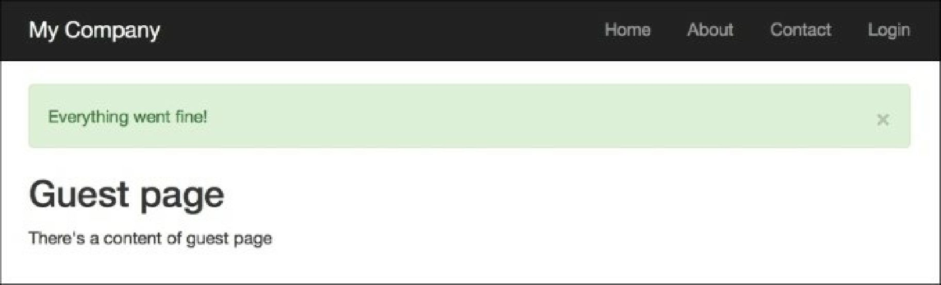

Moreover, if you go to http: //yii-book. app/index. php?r=test/error, you will be redirected to the same page, but with an error message. Refreshing the index page will hide the message:

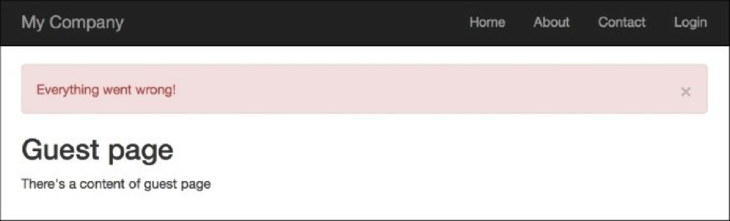

7. Then try running http://yii-book.app/index.php?r=test/user. You will be redirected to http: //yii-book. app/index. php?r=test/index and an error message will be displayed that executed in the denyCallback function:

